**Lab#3 Design web pages for mobile shopping application using HTML5, CSS3 and Bootstrap 5.**

**a)Home Page: list few products & few menus like category, registration, sign in and about us.**

**Final Outcome:**

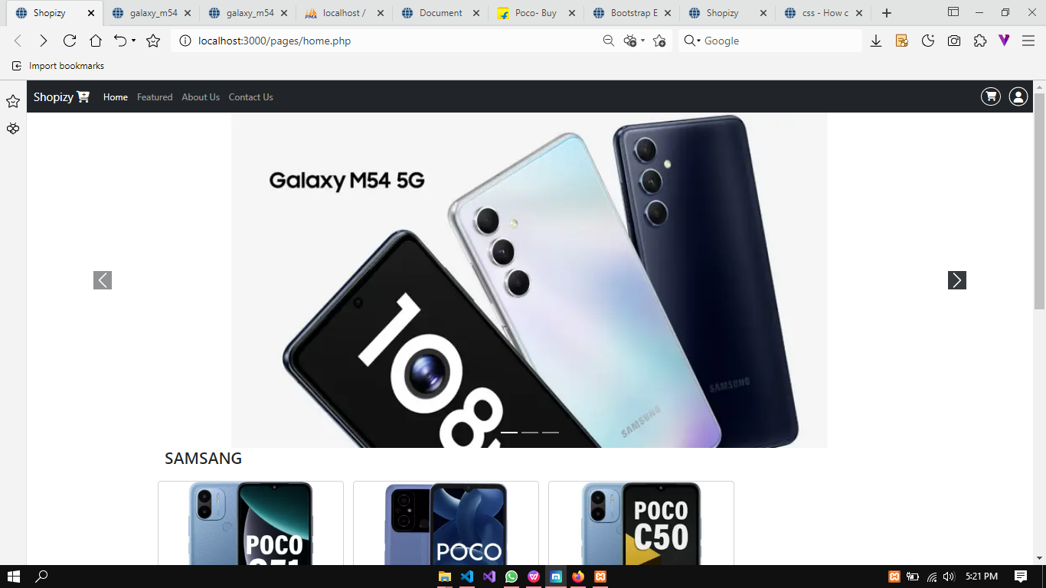

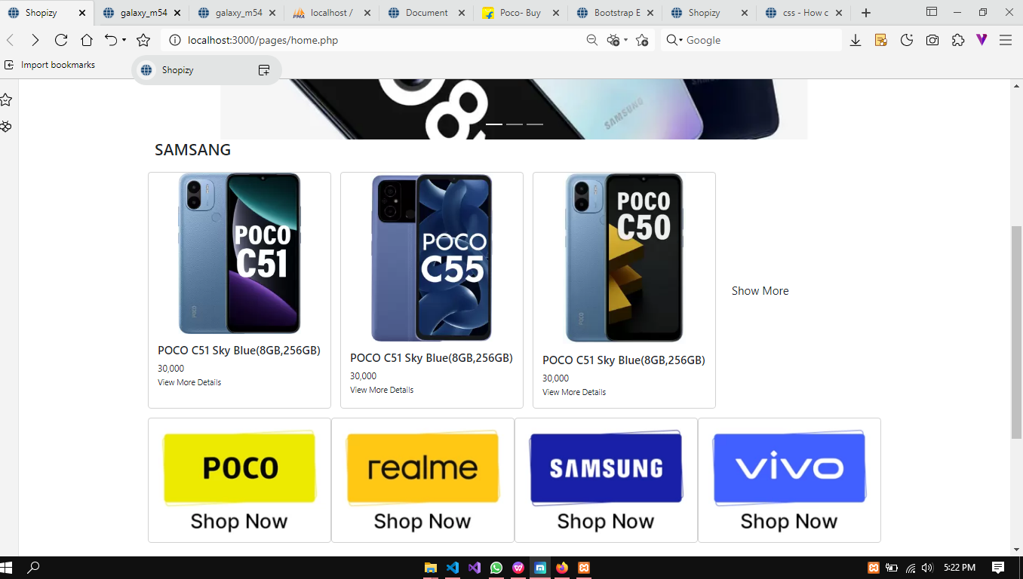

**Code Snippet:**

<!DOCTYPE html>

<html lang="en">

<head>

<title>Shopizy</title>

<meta charset="utf-8">

<meta name="viewport" content="width=device-width, initial-scale=1">

<link rel="stylesheet" href="home.css">

<link href="https://cdn.jsdelivr.net/npm/bootstrap@5.2.3/dist/css/bootstrap.min.css" rel="stylesheet">

<script src="https://cdn.jsdelivr.net/npm/bootstrap@5.2.3/dist/js/bootstrap.bundle.min.js"></script>

<link rel="stylesheet" href="https://cdnjs.cloudflare.com/ajax/libs/font-awesome/6.3.0/css/all.min.css">

</head>

<body>

<!--navbar start-->

<nav class="navbar navbar-expand-lg navbar-dark bg-dark text-white">

<div class="container-fluid">

<a class="navbar-brand" href="#">Shopizy&nbsp;<i class="fa-sharp fa-solid fa-cart-plus"></i></a>

<div class="collapse navbar-collapse" id="navbarScroll">

<ul class="navbar-nav me-auto my-2 my-lg-0 navbar-nav-scroll" style="--bs-scroll-height: 100px;">

<li class="nav-item">

<a class="nav-link active" aria-current="page" href="home.php">Home</a>

</li>

<li class="nav-item">

<a class="nav-link" aria-current="page" href="featured.html">Featured</a>

</li>

<li class="nav-item">

<a class="nav-link " area-curren="page" href="about.html">About Us</a>

</li>

<li class="nav-item">

<a class="nav-link " area-curren="page" href="contact.html">Contact Us</a>

</li>

</ul>

<div class="cart">

<a href=""><i class="fa-solid fa-cart-shopping"></i></a>

</div>

<div class="user">

<button onclick="<?php if($logged==false) echo 'openimg()'; else echo 'openProfile()'; ?>"><i class="fa-solid fa-user"></i></button>

</div>

</div>

</div>

</nav>

<!--navbar over-->

<!--this is image slider start-->

<div id="carouselExampleCaptions" class="carousel slide">

<div class="carousel-indicators">

<button type="button" data-bs-target="#carouselExampleCaptions" data-bs-slide-to="0" class="active" aria-current="true" aria-label="Slide 1"></button>

<button type="button" data-bs-target="#carouselExampleCaptions" data-bs-slide-to="1" aria-label="Slide 2"></button>

<button type="button" data-bs-target="#carouselExampleCaptions" data-bs-slide-to="2" aria-label="Slide 3"></button>

</div>

<div class="carousel-inner">

<div class="carousel-item active">

<img src="../images/slider images/galaxy_m54_5g.webp" class="d-block w-100" alt="...">

</div>

<div class="carousel-item">

<img src="../images/slider images/oppo f25.webp" class="d-block w-100" alt="...">

</div>

</div>

<button class="carousel-control-prev " type="button" data-bs-target="#carouselExampleCaptions" data-bs-slide="prev">

<span class="carousel-control-prev-icon bg-dark" aria-hidden="true"></span>

<span class="visually-hidden">Previous</span>

</button>

<button class="carousel-control-next" type="button" data-bs-target="#carouselExampleCaptions" data-bs-slide="next">

<span class="carousel-control-next-icon bg-dark" aria-hidden="true"></span>

<span class="visually-hidden">Next</span>

</button>

</div>

<!--image slider over-->

<div class="cards container mt-3 d-flex mb-3">

<div class="card col-3 p-2" onclick="window.open('poco.html')">

<img src="../images/logos/poco.jpg" alt="">

</div>

<div class="card col-3 p-2" onclick="window.open('realme.html')">

<img src="../images/logos/realme.jpg" alt="">

</div>

<div class="card col-3 p-2" onclick="window.open('samsang.htm')">

<img src="../images/logos/samsang.jpg" alt="">

</div>

<div class="card col-3 p-2" onclick="window.open('vivo.htm')">

<img src="../images/logos/vivo.jpg" alt="">

</div>

</div>

<!--Footer start-->

<!-- Footer -->

<footer class="text-center text-lg-start bg-white text-muted">

<!-- Section: Social media -->

<section class="d-flex justify-content-center justify-content-lg-between p-4 border-bottom">

<!-- Left -->

<div class="me-5 d-none d-lg-block">

<span>Get connected with us on social networks:</span>

</div>

<!-- Left -->

<!-- Right -->

<div>

<a href="" class="me-4 link-secondary">

<i class="fab fa-facebook-f"></i>

</a>

<a href="" class="me-4 link-secondary">

<i class="fab fa-twitter"></i>

</a>

<a href="" class="me-4 link-secondary">

<i class="fab fa-google"></i>

</a>

<a href="" class="me-4 link-secondary">

<i class="fab fa-instagram"></i>

</a>

<a href="" class="me-4 link-secondary">

<i class="fab fa-linkedin"></i>

</a>

<a href="" class="me-4 link-secondary">

<i class="fab fa-github"></i>

</a>

</div>

<!-- Right -->

</section>

<footer/>

<script>

function openProfile()

{

document.location='profile.php';

}

</script>

</body>

</html>

**b. Categories: display few products per each category and provide show more option for complete list.**

**Final Outcome:**

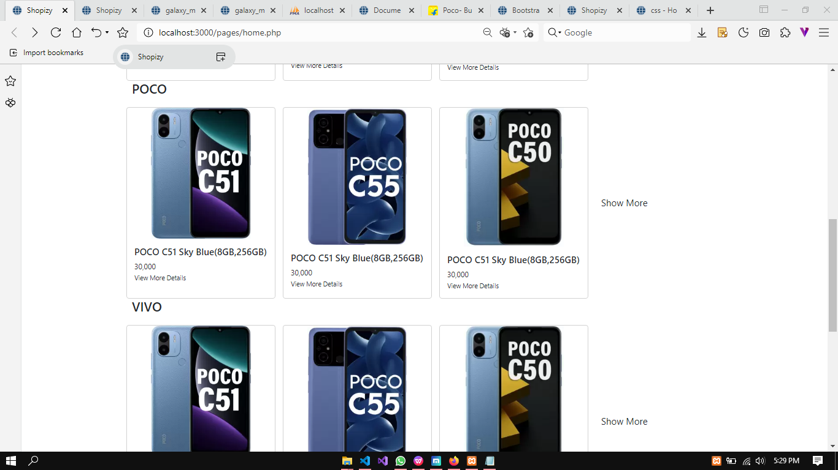

**Code snippet:**

<?php

function addCategory($cat)

{

echo ' <!-- category starts -->

<div class="poco container gap-3 m-auto row">

<h3>'.$cat.'</h3>

<!-- CARD 1 -->

<div class="card col-3" >

<div class="row d-flex justify-content-center">

<img src="../images/main images/c51-mzb0dxkin-poco-original-imagzdpycgrcdc8z.jpg" class=" w-75 h-100 " alt="...">

</div>

<div class="row">

<div class="card-body">

<h5 class="card-title">POCO C51 Sky Blue(8GB,256GB)</h5>

<span>30,000</span>

<p class="card-text"><small class="text-body-secondary">View More Details</small></p>

</div>

</div>

</div>

<!-- CARD 2 -->

<div class="card col-3" >

<div class="row d-flex justify-content-center">

<img src="../images/home images/-original-imagnfzyhh8gz8sd.webp" class=" w-75 h-100 " alt="...">

</div>

<div class="row">

<div class="card-body">

<h5 class="card-title">POCO C51 Sky Blue(8GB,256GB)</h5>

<span>30,000</span>

<p class="card-text"><small class="text-body-secondary">View More Details</small></p>

</div>

</div>

</div>

<!-- CARD 3 -->

<div class="card col-3" >

<div class="row d-flex justify-content-center">

<img src="../images/home images/-original-imaghmtch6qfmfxg.webp" class=" w-75 h-100 " alt="...">

</div>

<div class="row">

<div class="card-body">

<h5 class="card-title">POCO C51 Sky Blue(8GB,256GB)</h5>

<span>30,000</span>

<p class="card-text"><small class="text-body-secondary">View More Details</small></p>

</div>

</div>

</div>

<div class="col-2 d-flex flex-column justify-content-center link-offset-1-hover">

<a class="fs-5 text-dark text-decoration-none more " href="poco.php">Show More</a>

</div>

</div>

<!-- category starts -->';

}

addCategory('SAMSANG');

addCategory('POCO');

addCategory(VIVO);

?>

**c. User registration web page**

**Final outcome:**

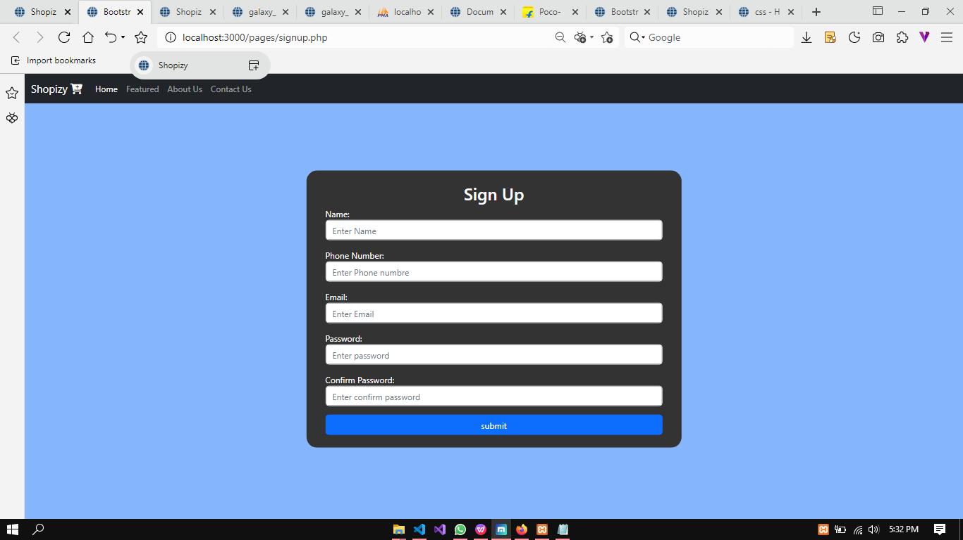

**Code snippet:**

<!--Form starts here-->

<div class="form-box-signup mt-4" id="demo" >

<div class="container mt-4 text-white">

<h2 class="text-center">Sign Up</h2>

<form action="" method="post" onsubmit="return handleSubmit()">

<div class="mb-3 mt-1 mx-4">

<label for="email">Name:</label>

<input type="text" class="form-control" id="name" placeholder="Enter Name" name="name">

<span class="error"> <?php echo $name_err;?> </span>

</div>

<div class="mb-3 mt-3 mx-4">

<label for="phone">Phone Number:</label>

<input type="text" class="form-control" id="phnum" placeholder="Enter Phone numbre" name="phone">

<span class="error"> <?php echo $mob_err;?> </span>

</div>

<div class="mb-3 mt-3 mx-4">

<label for="email">Email:</label>

<input type="email" class="form-control" id="email" placeholder="Enter Email" name="email">

<span class="error"> <?php echo $email_err;?> </span>

</div>

<div class="mb-3 mx-4">

<label for="pwd">Password:</label>

<input type="password" class="form-control" id="pwd" placeholder="Enter password" name="pswd">

<span class="error"> <?php echo $pass_err;?> </span>

</div>

<div class="mb-3 mx-4">

<label for="pwd">Confirm Password:</label>

<input type="password" class="form-control" id="cpwd" placeholder="Enter confirm password" name="cpswd">

<span class="error"> <?php echo $cpass_err;?> </span>

</div>

<div class="row mb-4 mx-4 mt-2">

<input type="submit" class="btn btn-primary" value="submit">

</div>

</form>

</div>

</div>

**d. Login page for User**

**Final Outcome:**

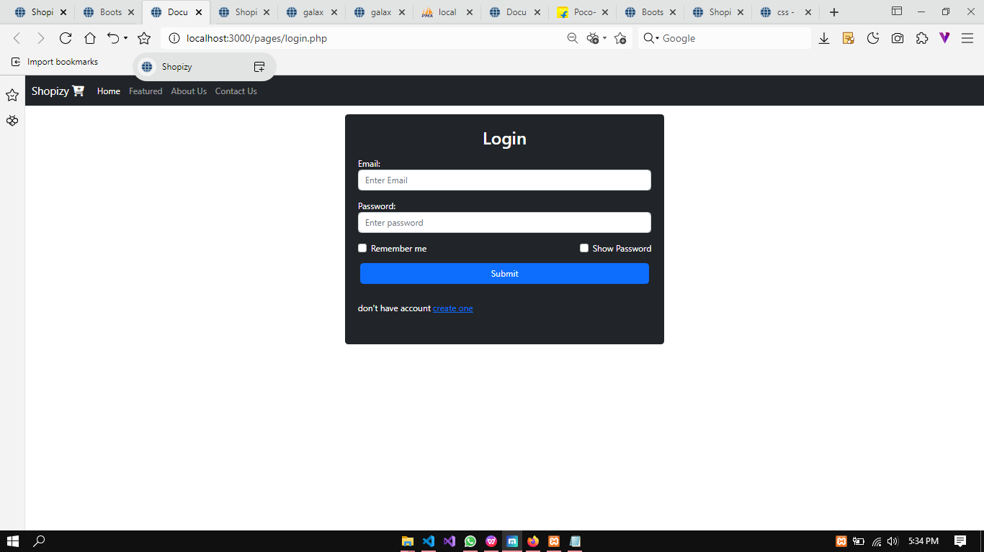

**Code snippet:**

<!--login form model-->

<div class="container bg-dark mt-3 p-4 rounded text-white col-4">

<h2 class="text-center">Login</h2>

<form action="profile.php" method="post" id="loginform">

<div class="mb-3 mt-3">

<label for="email">Email:</label>

<input type="email" class="form-control" id="email" placeholder="Enter Email" name="email">

<span class="error"><?php echo $email_err?></span>

</div>

<div class="mb-3">

<label for="pwd">Password:</label>

<input type="password" class="form-control" id="pwd" placeholder="Enter password" name="pswd">

<span class="error"><?php echo $pass_err?></span>

</div>

<div class="form-check mb-3 d-flex justify-content-between">

<label class="form-check-label me-5">

<input onclick="setCookie()" class="form-check-input" id="rem" type="checkbox" name="remember"> Remember me

</label>

<label class="form-check-label">

<input onclick="showPass()" name="spass" class="form-check-input" type="checkbox" id="showp"> Show Password

</label>

</div>

<div class="row mb-3 mt-3 mx-1">

<input type="submit" name="login" class="btn btn-primary">

</div>

<div class="py-3">

<p id="createac">don't have account <a href="signup.php">create one</a></p>

</div>

</form>

</div>

**e. Detailed product page**

**Final outcome:**

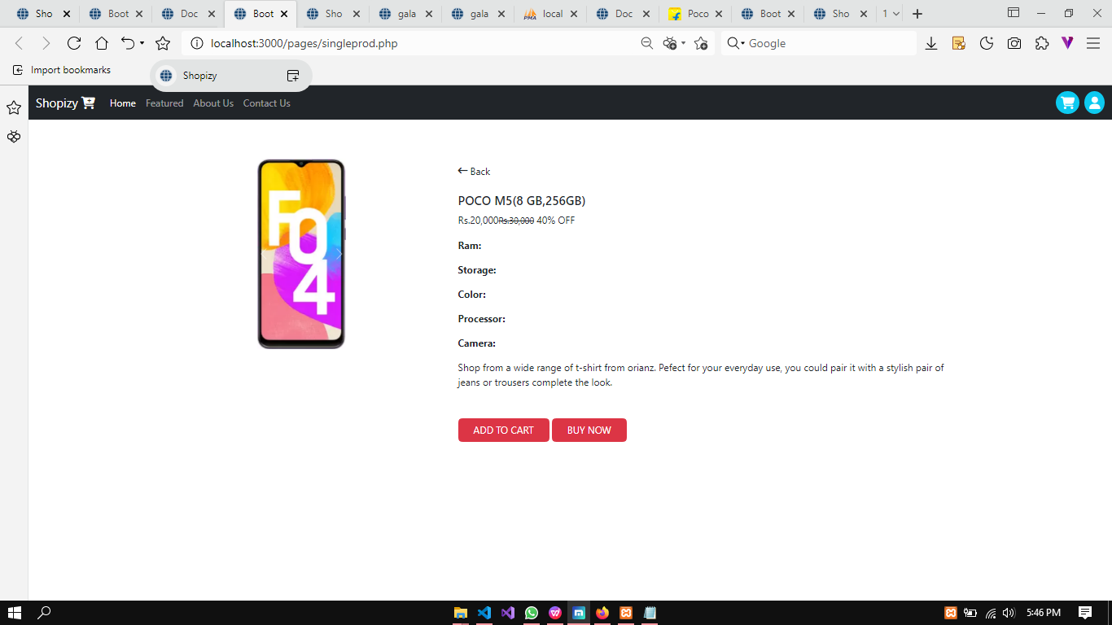

**Code snippet:**

<!-- PRODUCT DETAILS DIVISION STARTS -->

<div class="container mt-5 mb-5">

<div class="row d-flex justify-content-center">

<!-- images div starts -->

<div class="col-md-4 d-flex justify-content-center">

<!-- images starts -->

<div class="images p-3">

<!-- carouselExampleControls starts -->

<div id="carouselExampleControls" class="carousel slide" data-bs-ride="carousel">

<!-- carousel-inner start -->

<div class="carousel-inner">

<div class="carousel-item active"><img src="../images/main images/_original_imaghgbyypzkzvud.jpg" class="d-block w-70" alt="...">

</div>

<div class="carousel-item">

<img src="../images/main images/_original_imaghgbyypzkzvud.jpg" class="d-block w-70" alt="...">

</div>

<div class="carousel-item">

<img src="../images/main images/_original_imagq644cjzvgzsd.jpg" class="d-block w-70" alt="...">

</div>

</div>

<!-- carousel-inner end -->

<button class="carousel-control-prev" type="button" data-bs-target="#carouselExampleControls" data-bs-slide="prev">

<span class="carousel-control-prev-icon" aria-hidden="true"></span>

<span class="visually-hidden">Previous</span>

</button>

<button class="carousel-control-next" type="button" data-bs-target="#carouselExampleControls" data-bs-slide="next">

<span class="carousel-control-next-icon" aria-hidden="true"></span>

<span class="visually-hidden">Next</span>

</button>

</div>

<!-- carouselExampleControls ends -->

</div>

<!-- images starts -->

</div>

<!-- images div ends -->

<div class="col-md-8">

<div class="product p-4">

<div class="d-flex justify-content-between align-items-center">

<div class="d-flex align-items-center"> <i class="fa fa-long-arrow-left"></i> <span class="ml-1 ms-1">Back</span> </div>

</div>

<div class="mt-4 mb-3">

<h5 class="text-uppercase">POCO M5(8 GB,256GB)</h5>

<div class="price d-flex flex-row align-items-center"> <span class="act-price">Rs.20,000</span>

<div class="ml-2"> <small class=" text-decoration-line-through dis-price">Rs.30,000</small> <span>40% OFF</span> </div>

</div>

</div>

<div class="config">

<p class="fw-bold">Ram:</p>

<p class="fw-bold ">Storage:</p>

<p class="fw-bold ">Color:</p>

<p class="fw-bold ">Processor:</p>

<p class="fw-bold ">Camera:</p>

</div>

<p class="about">Shop from a wide range of t-shirt from orianz. Pefect for your everyday use, you could pair it with a stylish pair of jeans or trousers complete the look.</p>

<div class="sizes mt-5">

</div>

<div class="cart mt-4 align-items-center"> <button class="btn btn-danger text-uppercase mr-2 px-4">Add to cart</button> <button class="btn btn-danger text-uppercase mr-2 px-4">Buy Now</button> </div>

</div>

</div>

</div>

</div>

<!-- PRODUCT DETAILS DIVISION ENDS -->

**f.Admin Login:**

**Final outcome:**

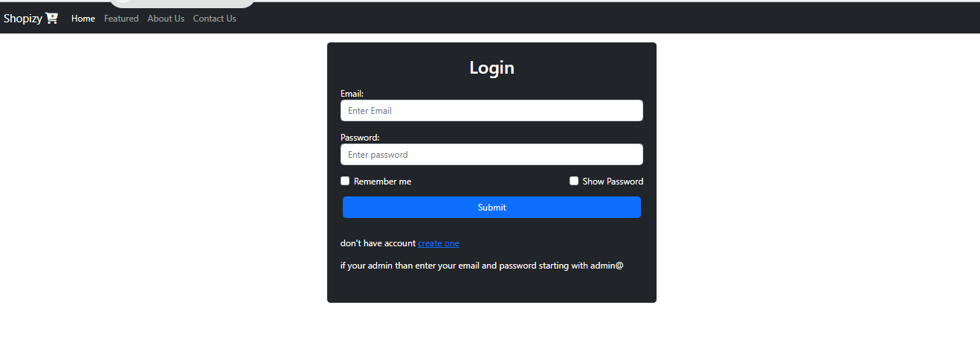

**g. Management of category & product (insert, update and delete product and categories)**

**Code snippet:**

<!DOCTYPE html>

<html lang="en">

<head>

<meta charset="UTF-8">

<meta name="viewport" content="width=device-width, initial-scale=1.0">

<title>Document</title>

<link href="https://cdn.jsdelivr.net/npm/bootstrap@5.2.3/dist/css/bootstrap.min.css" rel="stylesheet">

<script src="https://cdn.jsdelivr.net/npm/bootstrap@5.2.3/dist/js/bootstrap.bundle.min.js"></script>

<link rel="stylesheet" href="https://cdnjs.cloudflare.com/ajax/libs/font-awesome/6.3.0/css/all.min.css">

</head>

<body>

<h1 class="text-center" >UPDATE PRODUCT</h1>

<table class="table">

<thead>

<tr>

<th scope="col">PID</th>

<th scope="col">NAME</th>

<th scope="col">PRICE</th>

<th scope="col">COLOR</th>

<th scope="col">STORAGE</th>

<th scope="col">RAM</th>

<th scope="col">IMAGE1</th>

<th scope="col">DELETE</th>

<th scope="col">EDIT</th>

</tr>

</thead>

<tbody>

</tbody>

</table>

<script>

let btn=document.getElementById('deleteBtn')

btn.addEventListener('click',(e)=>{

console.log(e.target.parentNode.parentNode.parentNode.firstElementChild.innerText)

})

</script>

</body>

</html>

**Add product:**

<!DOCTYPE html>

<html lang="en">

<head>

<meta charset="UTF-8">

<meta name="viewport" content="width=device-width, initial-scale=1.0">

<title>Document</title>

<link href="https://cdn.jsdelivr.net/npm/bootstrap@5.2.3/dist/css/bootstrap.min.css" rel="stylesheet">

<script src="https://cdn.jsdelivr.net/npm/bootstrap@5.2.3/dist/js/bootstrap.bundle.min.js"></script>

<link rel="stylesheet" href="https://cdnjs.cloudflare.com/ajax/libs/font-awesome/6.3.0/css/all.min.css">

</head>

<body>

<div class="container bg-dark mt-3 p-4 rounded text-white col-6">

<h2 class="text-center">Add New Product</h2>

<form action="" method="post" enctype="multipart/form-data" id="loginform">

<div class="mb-3 mt-3">

<label>Name Of Product:</label>

<input type="text" class="form-control" id="name" placeholder="Enter Product Name" name="name">

</div>

<div class="mb-3">

<label>Price:</label>

<input type="text" class="form-control" id="price" placeholder="Enter Price" name="price">

</div>

<div class="mb-3">

<label>Color:</label>

<input type="text" class="form-control" id="color" placeholder="Enter Color" name="color">

</div>

<div class="mb-3">

<label>RAM:</label>

<input type="text" class="form-control" id="ram" placeholder="Enter RAM" name="ram">

<div class="mb-3">

<label>Storage:</label>

<input type="text" class="form-control" id="storage" placeholder="Enter Storage" name="storage">

</div>

<div class="mb-3">

<label>Processor:</label>

<input type="text" class="form-control" id="processor" placeholder="Enter Processor Name" name="processor">

</div>

<div class="mb-3">

<label>Camera:</label>

<input type="text" class="form-control" id="camera" placeholder="Enter Camera Details" name="camera">

</div>

<div class="mb-3">

<label>Image1:</label>

<input type="file" class="form-control" id="img1" placeholder="Enter image1:" name="img1">

</div>

<div class="mb-3">

<label>Image2:</label>

<input type="file" class="form-control" id="img2" placeholder="Enter image2:" name="img2">

</div>

<div class="mb-3">

<label>Image3:</label>

<input type="file" class="form-control" id="img3" placeholder="Enter image3:" name="img3">

<div class="row mb-3 mt-3 mx-1">

<input type="submit" name="add" value="ADD PRODUCT" class="btn btn-primary">

</div>

</form>

</body>

</html>

**OUTCOME:**

